MILESTONE 3: Automation using Flow Designer & Email Notification
When a student creates a new IT support ticket, they only need to enter the Caller Name and Short Description of the issue. The student does not need to manually select the Category or Subcategory. Once the ticket is submitted, a Flow Designer automation is triggered and evaluates the Short Description for predefined keywords such as WiFi, Projector, Password, or Slow. Based on the identified keyword, the flow automatically assigns the appropriate Category and Subcategory to the ticket.
- If the short description contains the word WiFi, the flow assigns Category = Network and Subcategory = WiFi.
- If the description contains Projector, the flow assigns Category = Hardware and Subcategory = Projector.
- If the description includes Password or Login, the flow assigns Category = Access and Subcategory = Forgot Password.
- If the description mentions Slow or Hanging, the flow assigns Category = Performance and Subcategory = Slow Computer.
This automation ensures consistent classification, eliminates human error, and significantly reduces the manual effort required by IT staff.
The entire process is implemented using Flow Designer, making the solution easy to maintain, scalable, and completely no-code.

Activity : 1 Auto Classification using Flow design.

- Go to All menus → Search Flow designer.
- Under Process Automation Open the Flow designer.
- On the top right corner Click New and Select Flow Option.
- Name : Auto Classify School IT Tickets.
- Application : Global.
- Now Click the Build Flow button.

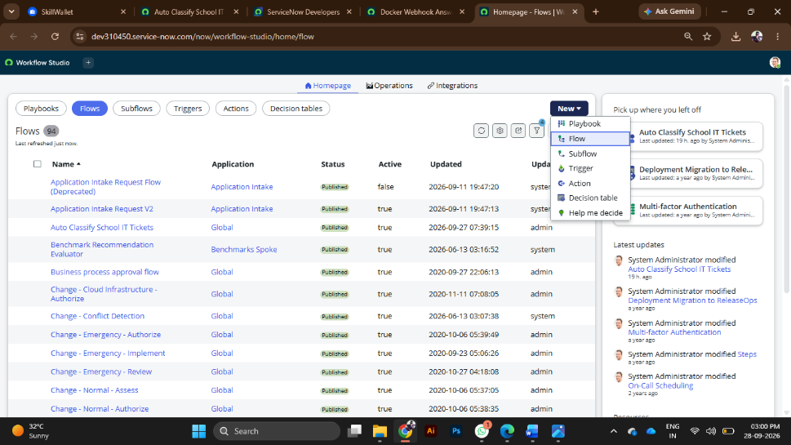

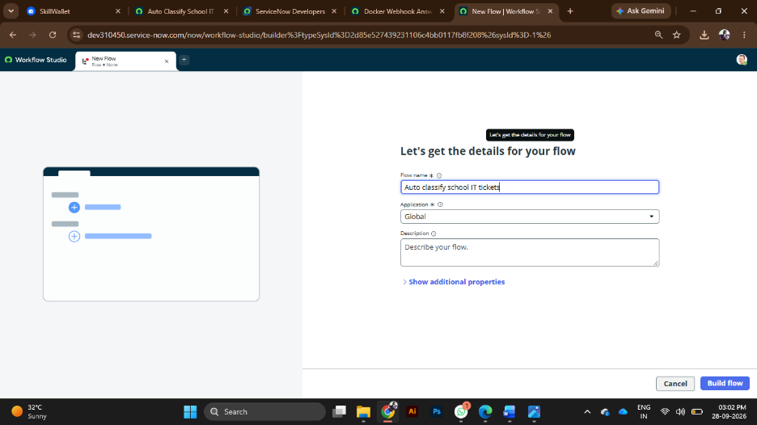

Activity : 2 Trigger Configuration.

- Trigger : Record Created.
- Table : Incident Workflow.
- Condition : Category is Empty.
- Then Click Done.

- Now Under Actions Select Flow Logic Option.

Activity : 3 Wi-Fi Issue Classification.

- Select If condition.
- Condition label : SD is Wifi or Network (Give as ur wish).
- Condition 1 : Using data pill picker Select Short description as Field , and operator Contains , Value is Wi-Fi.
- Condition 2 : Using data pill picker Select Short description as Field, and Operator is Contains, Value is Network.
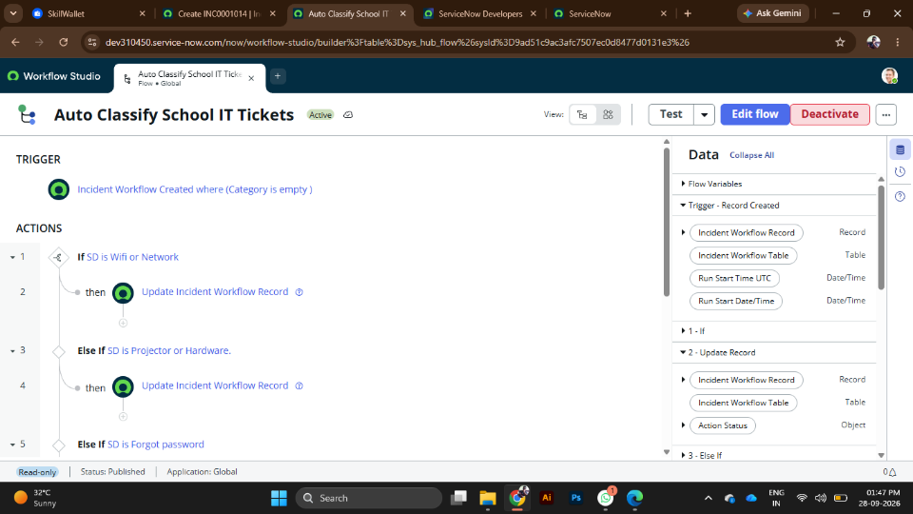
- Then Click Done Button.

- Now Click Action to Update record.
- Action Inputs.
- In Record Field drag and drop data from the right side.
- Table : Auto updates as Incident Workflow.
- Fields Set Category = Network.
- Set Subcategory = Wi-Fi.
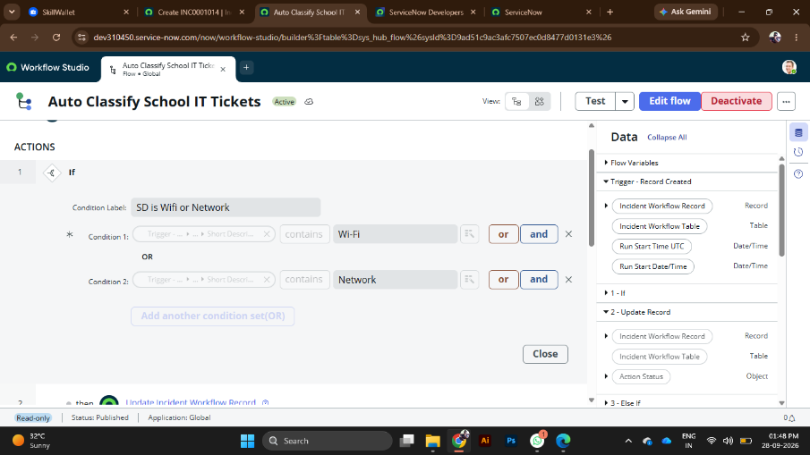
- Then Click the Done button.

Activity : 4 Projector Issue Classification.

- Now Select the Else If Condition.
- Condition label : SD is Projector or Hardware.
- Condition : Short description Contains Prajector.
- Then Click the Done button.
- Now Action is an Update record.
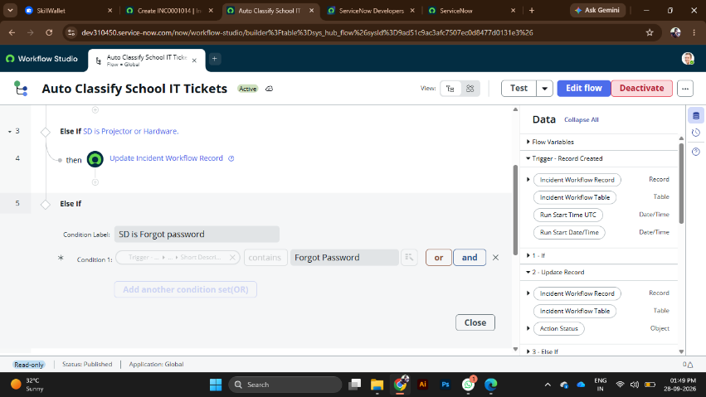
- Set Category = Hardware.
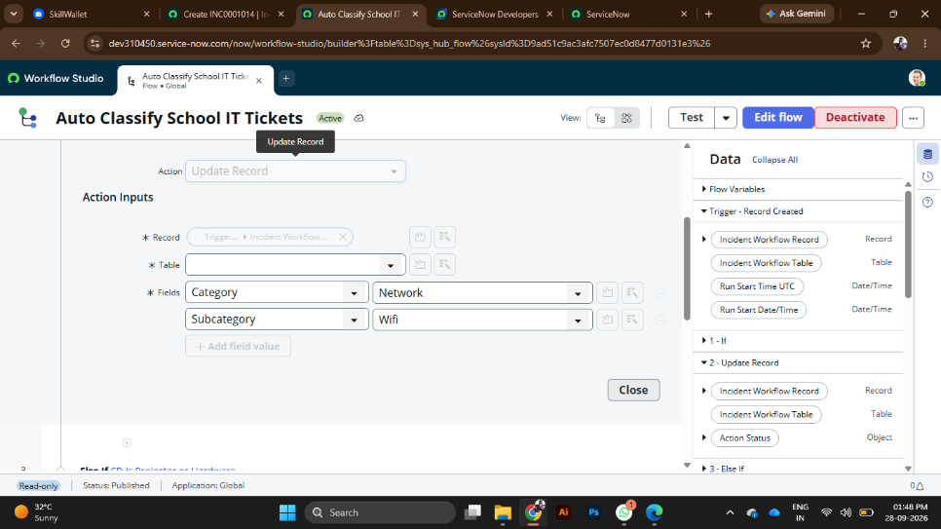
- Set Subcategory = Projector.
- Then Click the Done button.

Activity : 5 Password Issue Classification.

- Now again select Else If condition.
- Condition label : SD is Forgot password.
- Condition : Short description contains Forgot password.
- Then Click the Done button.
- Now Action is an Update Record.
- Set Category = Access.
- Set Subcategory = Forgot Password.
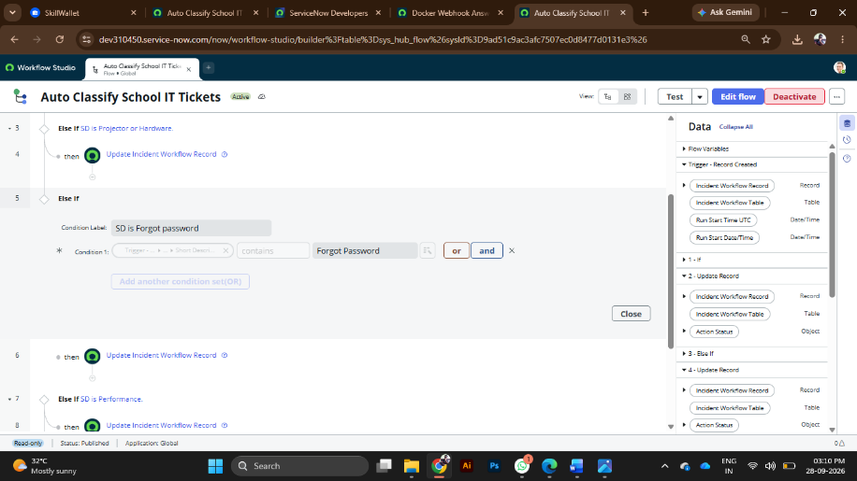
- Then Click the Done button.
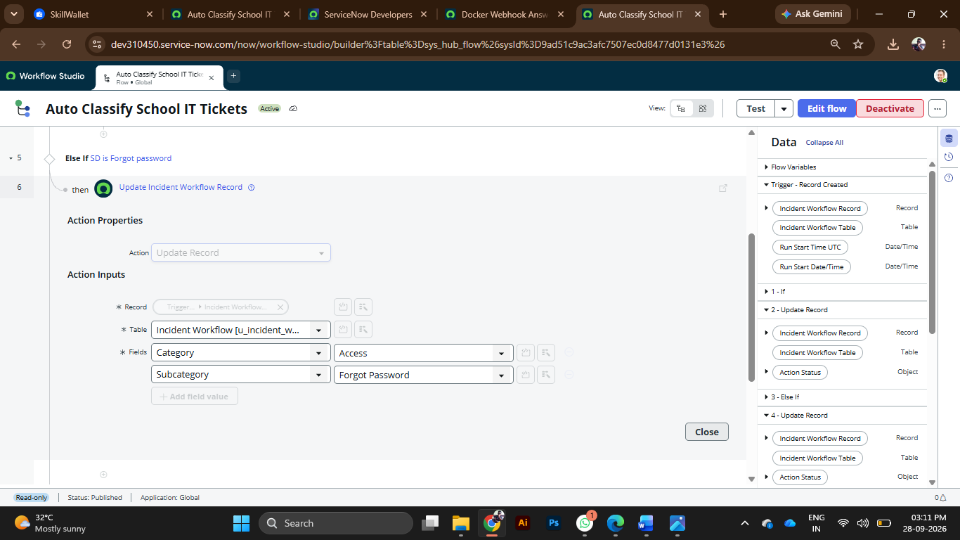

Activity : 6 Slow Computer Classification.

- Now Again Click the Else If Condition.
- Condition label : SD is Performance.
- Condition : Short description contains Slow Computer.
- Then Click the Done button.
- Now Action is an Update Record.
- Set Category = Performance.
- Set Subcategory = Slow computer.
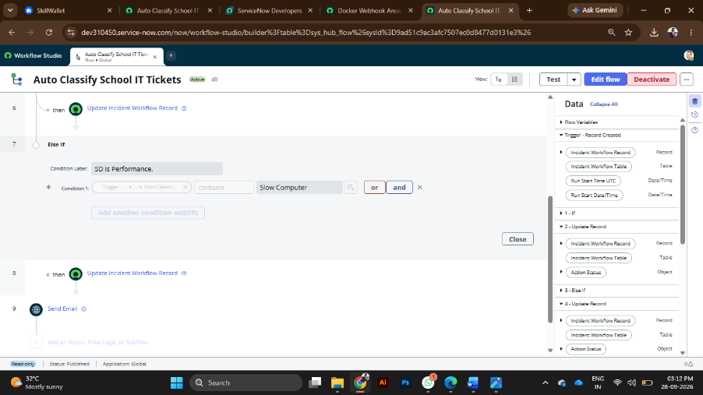
- Then Click the Done button.

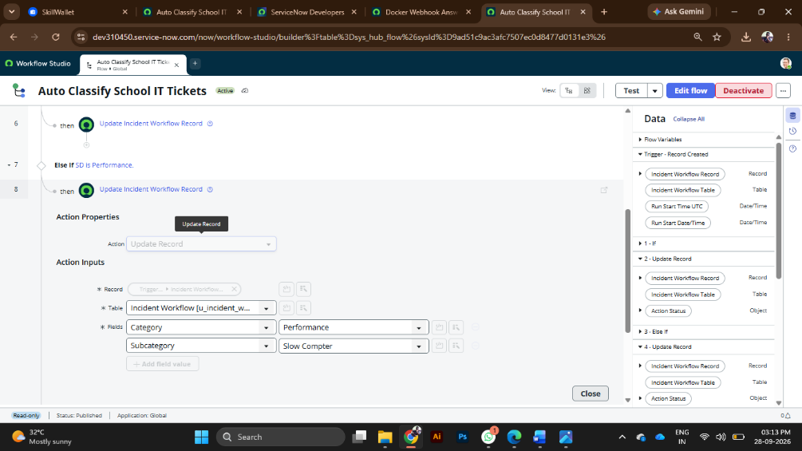

Activity : 7 Email Action Setup.

- After classification, an email notification is sent using Flow Designer.
- Set Action Send Email.
- To : Caller → Email.
- Subject : Your Request for the issue has been submitted.
- Body : Ticket confirmation message.
- Then Click the Done button.
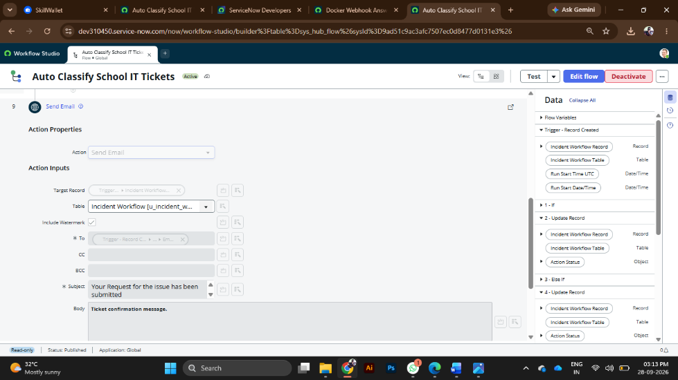

- Now Click the Activate button from the top right corner.

